Bearing witness

Reimagining in poetry the victims of the Babyn Yar massacre
By Askold Melnyczuk
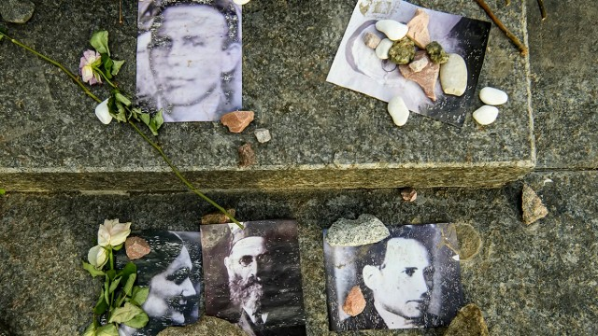
Portraits of Jewish victims at the Babyn Yar memorial, Kyiv |© Maxym Marusenko/NurPhoto via Getty Images
September 30, 2022
Read this issue

IN THIS REVIEW
VOICES FROM BABYN YAR
Translated by Oksana Maksymchuk and Max Rosochinsky
162pp. Harvard Ukrainian Research Institute. £12.95 (US $16).
Marianna Kiyanovska
In late September 1941, the German occupying forces posted the following orders in Russian, Ukrainian and German all around the city of Kyiv:
All Yids of the city of Kiev and its vicinity must appear on Monday, 29 September, by 8 o’clock in the morning at the corner of Mel’nikova and Dokterivskaya streets (near the Viis’kove cemetery). Bring documents, money and valuables, and also warm clothing, linen, etc. Any Yids who do not follow this order and are found elsewhere will be shot. Any civilians who enter the dwellings left by Yids and appropriate the things in them will be shot.
Apparently the Germans expected no more than 5,000 people to heed their summons. Instead, more than 30,000 Jews, most assuming they were to be deported, appeared near the ravine known as Babyn Yar, bearing their most prized possessions. And so, on September 29, began the most murderous two days of the Holocaust: 33,771 Jews were murdered. Over the months that followed the Nazis’ additional victims would include Ukrainian nationalists, Roma, and Soviet prisoners of war. In all, the mass grave was said to hold between 100,000 and 150,000 bodies.
“What is poetry that does not save / Nations or people?” asked the Nobel prizewinning Polish poet Czesław Miłosz. His answer: “A connivance with official lies, / A song of drunkards whose throats will be cut in a moment”. Marianna Kiyanovska’s daring sequence of dramatic monologues, Voices from Babyn Yar, is no song for drunkards. Neither is it an attempt to compensate for the “connivance with official lies” that was Soviet history-writing right up until the system’s collapse in 1991. It is, rather, a heroic project of retrieval, a demonstration of the imagination’s capacity to “witness” what it never saw.
Those able to read the poems in their original language will find themselves inside a whirl of intensities, a cacophony speaking to us with a startling and unsettling immediacy. (As an inflected language, Ukrainian is a singularly supple instrument for poetry; to their credit, however, the translators, Oksana Maxsymchuk and Max Rosochinsky, succeed in conveying the poems’ urgency in English.) Belonging mostly to Kyiv’s Jewish community, the imagined voices are wrenching. Kiyanovska’s keen ear brings us into intimate contact with her speakers. We feel their terror while experiencing surreal moments of hope: “the cries of the guards / break the silence in the ravine, it dawns on me / there’s no death, walking through rainbows of dew / Shelia says: it only seems barren and dark / come and see – joy and light, boundless, stark”.
Each soliloquy feels like a novel pared down to its essence. In one poem, the speaker sits beside his grandfather, who has been shot by a policeman. He explains to the old man that they have been summoned to Babyn Yar: “mama said we’ve been ordered to gather / they won’t shoot, it’s a promise”. The old man knows better. Recognizing that they have no choice, he advises “off you go, but first kill the cat”. In another, a man lying prostrate in the pit, awaiting his bullet, worries about who will now feed his homing pigeons. Such novelistic details give dimension and emotional weight to these brief lyrics.
“In order to bear witness I need not survive /… to survive in this war … would be a betrayal”, says one of the speakers. The speaker then claims to have only felt terror twice, once at the shooting of a friend and a second time when “mama told me how our David was burned / alive right in front of their house in Irpin near Kyiv”. Irpin happens to be the site of a recent massacre of Ukrainians by Russian troops. What began as a project aimed at “history” has become irrevocably fused with current events. On March 1, 2022, Babyn Yar was struck by a Russian missile.
It has been argued that Babyn Yar was a test case for Hitler. Had the world responded appropriately in September 1941, the discussion among the Nazi elite a few months later on Lake Wannsee in Berlin might have gone very differently. Instead, emboldened by the world’s silence, Adolf Eichmann proposed the final solution to “the Jewish question”. Such reflections prompt one to wonder: had the world’s response to Russia’s attack on eastern Ukraine and Crimea in 2014 been different, where might we be today?
“No one will write about us”, laments one of Hitler’s victims in Marianna Kiyanovska’s book. Both the illuminating introduction by the poet Polina Barskova and the translators’ foreword refer to the “controversial” matter of “cultural appropriation”. Yet poets from Homer to Robert Browning to Edgar Lee Masters to Tyehimba Jess have made it their business to inhabit the lives of strangers, living and dead. What matters is the emotional persuasiveness of the presentation. There is no doubt that Voices of Babyn Yar is destined to become a classic text in the Ukrainian canon. Will this poetry save nations or people? Of course not. But it will forever serve as a reminder of the human capacity for evil – a prompt we seem to require on a regular basis.
Askold Melnyczuk’s most recent book is the short story collection The Man Who Would Not Bow, 2021. He has translated Oksana Zabuzhko and Ivan Drach, and is currently working on translations of Marjana Savka’s Selected Poems

